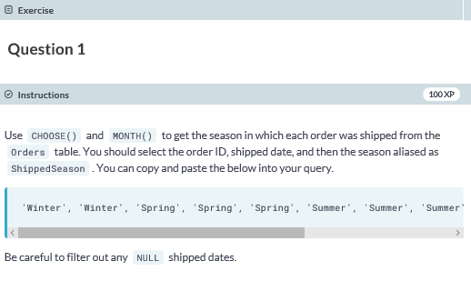

**SELECT OrderID, ShippedDate,**

**CHOOSE(MONTH(ShippedDate),'Winter', 'Winter', 'Spring', 'Spring', 'Spring', 'Summer', 'Summer', 'Summer', 'Autumn', 'Autumn', 'Autumn', 'Winter') AS 'ShippedSeason'**

**FROM dbo.Orders**

**WHERE ShippedDate IS NOT NULL;**

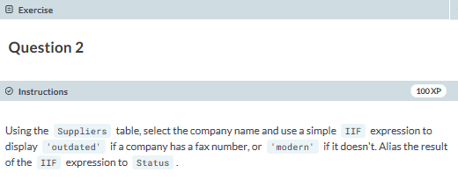

**SELECT CompanyName, IIF(Fax IS NULL,'modern','outdated') AS 'Status'**

**FROM dbo.Suppliers;**

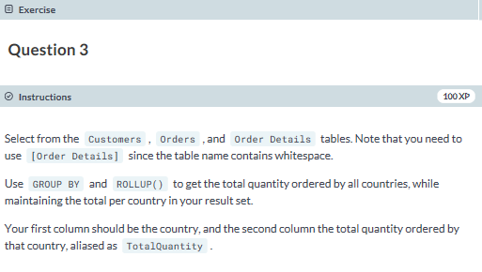

**SELECT c.Country, SUM(od.Quantity) AS TotalQuantity**

**FROM dbo.Customers AS c**

**JOIN dbo.Orders AS o**

**ON c.CustomerID = o.CustomerID**

**JOIN dbo.[Order Details] AS od**

**ON o.OrderID = od.OrderID**

**GROUP BY ROLLUP(c.Country);**

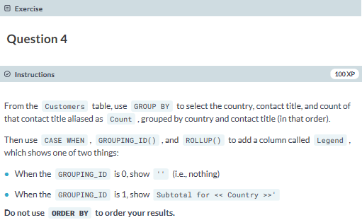

**SELECT Country, ContactTitle, COUNT(ContactTitle) AS 'Count',**

**CASE**

**WHEN GROUPING_ID(Country, ContactTitle) = 0 THEN ''**

**WHEN GROUPING_ID(Country, ContactTitle) = 1 THEN 'SubTotal for '+Country**

**END AS 'Legend'**

**FROM dbo.Customers**

**GROUP BY ROLLUP(Country, ContactTitle);**

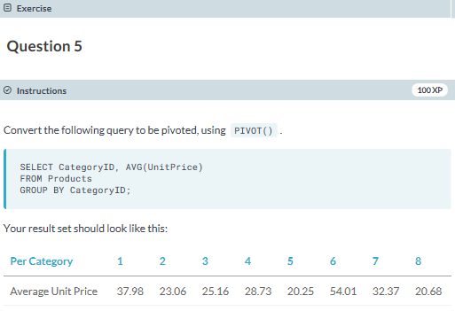

**SELECT 'Average Unit Price' AS 'Per Category',[1],[2],[3],[4],[5],[6],[7],[8]**

**FROM**

**(SELECT CategoryID, UnitPrice**

**FROM Products) AS s**

**PIVOT**

**(AVG(s.UnitPrice) FOR s.CategoryID IN ([1],[2],[3],[4],[5],[6],[7],[8])) AS PivotTable;**

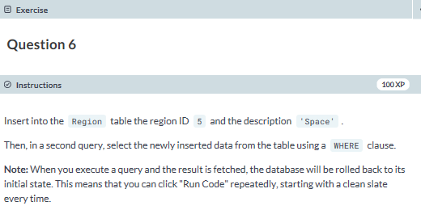

**INSERT INTO dbo.Region VALUES(5,'Space');**

**SELECT * FROM dbo.Region WHERE RegionID = 5;**

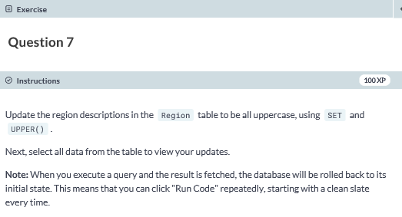

**UPDATE dbo.Region**

**SET RegionDescription = UPPER(RegionDescription);**

**SELECT * FROM dbo.Region;**

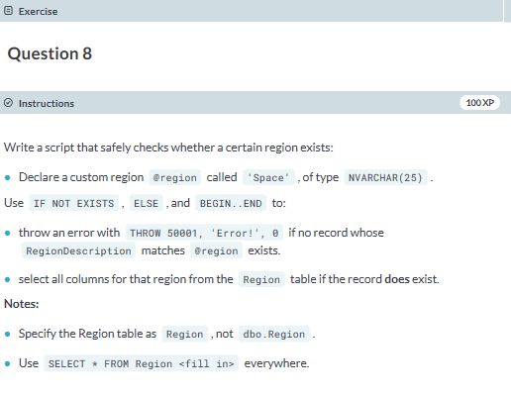

**DECLARE @region AS NVARCHAR(25) = 'Space';**

**IF NOT EXISTS (SELECT * FROM Region WHERE RegionDescription = @region)**

**BEGIN**

**THROW 50001,'Error!',0**

**END**

**ELSE**

**BEGIN**

**SELECT * FROM Region WHERE RegionDescription = @region;**

**END**